**inFlo**

**Picture or Logo (Optional)**

**Idea Summary for the Duke Start-Up Challenge**

**October 29, 2013**

Andrew Koff, Pratt School of Engineering, 2014, Andrew.Koff@duke.edu

Sean Scott, Trinity College of Arts & Sciences, 2015, sas75@duke.edu

**Write a summary description: In a few paragraphs, describe what problem you are solving, how many people are experiencing the problem, and what your solution is.**

Vast technological advancements have allowed companies across all sectors to obtain data at an increasing rate. As more and more information is being generated, efficient methods of analysis and reporting are essential for a business to thrive in today’s operating environment. However, there are currently no computer software tools that allow for the painless analysis and reporting of such large amounts of data. The quantity and sophistication of the information is far too great for the current analysis tools to efficiently generate results. Thus, much of the data analysis that could be generated to develop and modify profitable business strategy and tactics is instead going unnoted, creating substantial opportunities. inFlo’s proprietary software tool offers improved data visualization, analysis and interpretation of big data that allows clients to leverage all their data for new insights and new business opportunities. Companies will decrease the time between data ingestion and strategy selection and thus gain actionable insight from applicable large datasets.

inFlo will capitalize on its software’s potential to create monetary value to businesses by offering a unique method to effectively utilize large data in their respective markets. inFlo’s multivariate analysis software solution greatly facilitates the interpretation and analysis of massive datasets in a time-efficient, simple manner. For example, inFlo’s software makes it much easier for anyone not only to create plots and develop new correlations and parameters, but also to perform advanced filtering of data in order to present the data in the most informative way possible.

inFlo aims to ease the process of data collection and conversion through the utilization of its software tool, Multigraph. Current tools require a large amount of time and experience to be utilized to their full potential, and they are also very expensive. InFlo’s unique software tool condenses the time between data collection and analysis by implementing algorithms that quickly import and organize incredible amounts of data in an intuitive manner. With Multigraph, the large amount of time sifting through and organizing datasets is eliminated so that analysis efforts become more productive and the results produced are more actionable. According to user trials and preliminary analysis, efficiency increases are approximately tenfold. Multigraphwas designed with the intention of providing both superior analysis capabilities and strong reporting capabilities. inFlo’s Multigraph provides businesses with a single tool that converts data to tangible profits.

The technological environment in which we live today can be very complex and overwhelming. With Multigraph, data visualization, analysis and interpretation efforts of all sizes can be easily conquered. All of today’s industries are studying data at significantly increased rates, creating a need for a tool that substantially improves efficiency and comfort in this unfamiliar and overwhelming environment. Industry reports show that the total big data market in the United States reached $11.59 billion in 2012, and it is projected to reach $18.1 billion in 2013, an annual growth of 61%.[1] inFlo’s software tool will capitalize on this opportunity because it offers superior graphical analysis and reporting capabilities, allowing for automated data updates and live filtering, built as a multidimensional tool with connectivity for internal and external data not offered by conventional analytic visualization software tools.

**Tell us more about the problem you are solving.  Why is it a problem and how big of a problem is it?**

With current data analysis solutions, extreme amounts of time and technical expertise are required for actionable data insights to be produced. As business environments become increasingly reliant on data, companies can improve their business strategy and tactics by employing methods that efficiently organize and report the data. This issue has been occurring across all verticals, both inside the tech industry and beyond, because companies are increasingly using data to improve their day-to-day business strategy and tactics. Analytics’ efforts have increased tremendously over the past decade as a result of the premium placed on this information. Effectively harnessing and utilizing this information could have an extremely positive impact on a company’s future.

When analyzing and interpreting data, it is important to be able to rapidly compare different sets of data and to construct new correlations and parameters based on that data. For example, at this time many people use Microsoft Excel to do such analyses. However, Excel is very awkward to use, particularly when trying to quickly change the parameters being plotted or when calculating new parameters to plot, especially when many different large data sets are involved. InFlo’s solution, MultigraphTM, automatically gathers, sorts, manipulates and plots the data with very little effort by the user. For example, suppose there were 10 data sets containing 10 variables each and a total of 1000 data points. inFlo’s software allows plotting any ‘Y’ parameter versus any ‘X’ parameter of the same range by entering two values and pressing a button. Similarly, a new variable could be calculated for all 10 data sets (for all 100 points in each) by entering the formula once. In contrast, it would take even an experienced Excel user dozens of operations and about 10X the time to achieve the same results. Even for small data sets, inFlo’s software makes it much easier for business analysts to make plots and calculate new parameters, as well as to filter certain ranges of data, and rapidly change colors, symbols, and/or line types in order to present the data in the most informative way possible.

Due to the difficulty in gathering, analyzing and interpreting large datasets, highly trained analysts are hired in all business sectors to conduct analyses that ultimately shape business strategy and tactics. These analysts continue to use tools such as Microsoft Excel and Matlab despite the various analytics systems and business intelligence software tools available. Such analytics systems are avoided due to their inability to handle extreme amounts of data, the technological skills required to use them, and the high price to acquire them. Although Matlab and Excel are proven products, as noted from the wide range of users worldwide, they developed as large-scale analytics tools for companies that are constantly generating and processing new information. Who wants to organize, filter, store, plot and create reports for hundreds of datasets with thousands of variable columns using existing software tools? We sure don’t. As a result, companies are unable to study their data efficiently and are required to spend astronomical amounts of time and money employing qualified analysts to do the job. Whereas businesses must currently hire a large number of analysts to divide and conquer the work, inFlo can increase the productivity of each individual analyst by at least ten times! Companies will find that inFlo’s software tool adds significant monetary value because it reduces substantially the time between the collection of data and production of actionable insight in an efficient and cost effective manner. Multigraphmakes big data visualization, analysis and interpretation more affordable and accessible.

**Who do you think your target customers are and how many are there?**

How many analysts currently use Microsoft Excel or Matlab to plot and analyze big data? It would be hard to find one who doesn’t. More specifically, inFlo’s target customers are technical analysts at small, medium and large size companies in industries such as engineering, manufacturing, finance, consumer marketing and consulting that seek to improve data analysis efforts with a cost-effective and user-friendly solution. Multigraph is mainly geared toward frequent Microsoft Excel users and aims to provide them with a powerful software that can be leveraged to analyze, report, and display collected data. The product has an intuitive interface that allows for a short learning curve without sacrificing functionality. inFlo’s goal is to make Multigraph the tool that analysts rely on when conquering big data.

Since primary uses of Excel include storing, organizing, manipulating and plotting data, this product should appeal to anyone that uses Excel on a regular basis, therefore making the potential market for the Multigraph huge. It also should appeal to anyone that deals with data in general. Microsoft reports that as of 2004 there were over 500 million Microsoft Excel users worldwide. Therefore, if we assume that out of that group one-fifth are power Excel users, roughly 100 million users worldwide are the target customers for Multigraph.

**Do you think your customers are looking for a solution?**

Businesses of all types, in all industries, are looking for methods to adapt to the complex data-driven environment in which they function. All companies seek to grow and generate large profit margins; in order to do so, they need sound business strategy and tactics as well as methods for effective decision-making. Large analytics teams are employed to understand vast amounts of new data and organize it into valuable, actionable business intelligence. Frustration in the marketplace is common as a result of the large amount of capital spent toward assembling and operating large analytics teams. Frustration also stems from the inefficiencies of the current analysis tools. The analysts themselves are also frustrated because of the time that they are required to dedicate to the compilation and organization of data rather than toward productive analysis.

With Multigraph, analysts can increase productivity at least ten times and can offer more relevant analysis and data interpretation to their respective companies. Companies are currently overwhelmed with trying to hire and manage a sufficient number of analysts to digest even just a small portion of generated data. Therefore, they support and encourage improved software tools because an increase in productivity of analysis leads to a better understanding of the market, catered business strategies, and thus greater business success. The void in the marketplace is clear: a powerful, cost effective solution is needed.

????????? Are they satisfied with what is out there? Have they tried everything and other solutions just don't work? Often times a company's biggest competitor is that the "customers are ok doing nothing".  Given a choice of using your solution or doing nothing, what will they do.?????????

**Tell us about your solution.  How does it work and what are the benefits?**

Multigraph is data analysis software written in Visual Basic .NET that organizes and stores enormous datasets in order to have variables readily available for reporting and multivariate analysis. It also serves as a data-mining tool for analyzing specific business issues by developing correlations, mathematical analysis and dimensional analysis. inFlo’s software ingests data, in .csv file format by default, and organizes the variables in an intuitive array for quick identification and selection. One main function of Multigraph is its ability to rapidly create multiple side-by-side two-dimensional plots of several parameters plotted against several other parameters that facilitates the interpretation of complex multivariate data analysis. The tool has an interface that is simple and easy to navigate, shortening the learning curve and allowing users without specific training to benefit from it as well. Countless data variables of all types are stored and easily accessed through the software, allowing users to filter and plot the current and necessary business information. By incorporating a clever algorithm to organize the imported data, Multigraph is a powerful tool that aids in overcoming the data analysis hurdle faced by many industries and improves data analysis productivity.

**Do you have intellectual property (IP) that can be protected?  Is it protected?**

Currently, we are in the process of evaluating all aspects of inFlo’s software for which we will need copyrights or patents. We anticipate that a patent will be necessary to protect its unique data collection and storage methodology; therefore, once completely finalized one will be submitted. Also, it is anticipated that multiple portions of inFlo’s software code will require protection via copyrights.

**What's your plan for developing your product or service including some dates and milestones?**

First and foremost, we plan to have a fully functional product in a stand-alone environment completed in January of 2014. Currently inFlo’s prototype analysis tool is fully functioning as a workbook in Excel, written using VBA macros. Therefore, inFlo chose to move the product to a stand-alone environment not only as strategic business decision for increasing the pipeline of the company but also in order to improve capabilities for the tool. Once completed, during Q1 of 2014, we will begin to expand beta testing of Multigraph in order to upgrade the value and user experience. Also, we will be conducting business meetings with industry leaders in various sectors in order to increase exposure for the product as well as receive feedback for the future.

With investments, during Q2 and Q3 of 2014, we would like to begin improving processing and data storage by purchasing server space in order to initiate inFlo’s web application development project. This will allow inFlo’s product to incorporate real-time analytics for on-the-fly data analysis as well as the ability to store large amounts Multigraph data externally. As a company, we feel that this project could improve user experience and pipeline for future product offerings.

**Tell us about your competitors and the competitive landscape**

Given how painful it is to use Microsoft Excel and other widely used data analysis software tools, especially with multiple data sets or when making many different plots, we are surprised that a fairly extensive search identified NO competitors that offered the features of inFlo’s product. Therefore, in spite of its major limitations, Microsoft Excel is at this time the benchmark product in the industry for data analysis. Microsoft Excel is a convenient software package for financial, engineering and other data analysis, and is widely used by businesses for those purposes. But the plotting utility within Excel is quite limited and cumbersome to use when creating the many plots necessary to analyze and interpret large-volume datasets, thus creating an opportunity for inFlo’s software to penetrate its market share. For example, when creating numerous two-dimensional plots involving several parameters plotted against several other parameters measured during an engineering test program, Microsoft Excel’s plotting utility requires much repeated effort, takes substantial time to use, and is generally difficult to use.

Another potential competitor to inFlo’s software is Matlab. Relative to Excel, Matlab is a much more expensive option and requires more technical capabilities from the user. Although Matlab is powerful, it was developed to handle advanced mathematical and engineering analysis. As with Excel, Matlab is similarly quite limited to use when creating the many plots necessary to analyze and interpret large volume datasets.

Although these are two commonly used tools, they were not designed to handle and analyze the massive amounts of data that companies are collecting currently. The product we are developing will be primarily used for expansive and quick multivariate analysis but will also serve as a convenient reporting mechanism for data as well.

Along with Microsoft Excel and Matlab, there are various companies in the business intelligence sector as well as the web analytics sector. These tools, although capable of collecting large amounts of data, are primarily reporting mechanisms and are very expensive. Main competitors in the web analytics space are Adobe, Google, comScore, and IBM, all of which are expensive solutions except for Google’s free tool, Google Analytics. Again, as with Excel and Matlab, these tools are quite limited and cumbersome to use when creating the many plots necessary to analyze and interpret large volume datasets. They are geared toward analyzing web data collected by using a JavaScript tag that feeds data to their servers which organizes it for analysis. Although inFlo’s solution could be used effectively for web data reporting, we are targeting more broad use cases for multivariate data analysis.

In the business intelligence software space, companies such as SAS, Tableau Software and Domo provide tools for visualizing data. These tools are developed with the intention of generating visual aids for data presentation and high-level business reports. While inFlo’s product can function as a tool for high-level data reporting, inFlo’s Multigraph also provides companies with a solution that allows for a granular view of data so that detailed actionable analysis of large datasets can lead to improved business strategy, tactics and profitability. inFlo’s software is more powerful and easier to use than any other similar software in the market today and offers an unmatched 10 times improvement in data analysis productivity. In short, our diligent search has found no other software that provides users with all benefits of Multigraph.

**How much funding to get to a company exit?**

Upon successful deployment of inFlo’s software tool, Multigraph, we will seek to sell the business to a third party for a significant earnings multiple. Based upon current predictions of market size for data analytics and visualization software, inFlo can be expected to earn a sales premium of up to four times earnings. Because inFlo’s software can be sold directly to users, developed and sold in partnership with large software developer, sold to users through consulting business, the company will be able to offer investors many alternative exit methods. Based upon projected worldwide revenues of inFlo’s software of 500 million dollars annually the projected funding to get to a company exit is 10 million dollars.

**SAMPLE CALCULATION**

**Tell us about yourselves (Who is on your team, what are you studying, what year are you)**

Owners:

**Andrew Koff – Mechanical Engineer**

**Sean Scott, Computer Science and Mathematics, Class of 2015**

Sean Scott has always had a drive to solve challenging problems that are fundamental to the human experience. Originally aspiring to the field of theoretical physics, Scott was diverted from this path when he fell in love with computer programming in his freshman year at Duke. He has since found his calling in the field of artificial intelligence, a science that will soon change the way humans view intelligence and themselves. Towards this end, he has performed artificial intelligence and machine learning research with Duke Professors Ronald Parr and Mauro Maggioni, and he plans to pursue a PhD following completion of his Bachelor of Science degrees. He currently works as a data analyst and programmer for EPIS, Inc., a software developing company that focuses on modeling in the energy industry.

Given his background, it was an obvious choice to found inFlo and begin commercialization of Multigraph with his close friend Andrew Koff. Multigraph seamlessly combined his tried practical experience as a software developer with his theoretical experience with AI, which often deals with the organization of large datasets, colloquially known as Big Data. However, the essence of his connection to Multigraph is something greater. To him, Multigraph is not just a product; it will change the way humans work.

Advisor/Client:

***Kent A. Lyons, Chief Engineer of Compressors, Engine Performance and Data Analytics***

Mr. Lyons has a total of 39 years of experience leading and carrying out aerodynamic and structural design and redesign, resolution of difficult in-service field issues, and advanced design system development of high efficiency commercial aircraft engine fans and compressors, and high efficiency industrial gas turbine compressors. He also led the application of data analytics to optimize the design and operation of industrial compressors and gas turbines, and has been regarded as a top mentor for training young international engineers. Mr. Lyons received B.S. and M.S. degrees from Rensselaer Polytechnic Institute, and then worked at Pratt & Whitney (“P&W”) in Hartford, Connecticut for 26 years designing and developing fans and compressors for primarily commercial aircraft engines. In 2000, he transferred to Mitsubishi Power Systems in Miami, Florida as the Chief Engineer, Compressors and led the design, redesign, field issue resolution and design system development of high efficiency industrial gas turbine compressors. In 2006 at the request of Mitsubishi, Mr. Lyons joined TurboVision.

At P&W, Mr. Lyons carried out and led fan and compressor design and redesign for the JT8D and JT9D low pressure compressors, PW2037 high pressure compressor, Siemens V84.3A and V94.3A compressors, PW4000 fan and high pressure compressors, and PW6000 high pressure compressor. He also resolved and led the resolution of numerous critical field issues involving the PW4000 high-pressure compressor stability problems, rapid oxidation damage and icing damage, and was regarded as P&W’s top engineer to resolve such compressor problems. Additionally, Mr. Lyons developed and led the development of numerous advanced compressor design systems many of which are still in use today at P&W, including, a meanline design system for accurate conceptual and preliminary design, several streamline design system improvement features for accurate and rapid detailed design (e.g., streamline blockage model, integrated core/endwall streamline design, neural net cascade system, and a 3D post processor), airfoil structural tuning design system for rapid detailed designs, swept airfoil and 3D shroud design systems for high efficiency high speed fans, and innovative rain/hail ingestion and icing simulations that were FAA approved for engine certification eliminating very expensive engine test certifications.

At Mitsubishi, Mr. Lyons was the Chief Engineer, Compressors and led design and redesign projects for Mitsubishi Heavy Industries’ (“MHI”) compressors, including, M701FS air and gas compressors which are part of a successful and unique engine system that compresses and burns waste blast furnace gas from process industries to generate electricity, M701F compressor upgrade for increased power output applying a novel and industry-first “Hot Day” design concept, MF111B compressor upgrade for increased power output, and advanced 100 MW class two-shaft gas turbine high efficiency high pressure ratio compressor. He also led the resolution of compressor field issues involving MHI’s advanced M501H, M501G, M701F and M701FS engines. Additionally, Mr. Lyons led the development of MHI’s compressor design systems, including, a meanline design system for rapid and accurate conceptual and preliminary design, Rapid Airfoil Design System that demonstrated a reduction of 5.5 man-years of design time relative to the previous system for a high efficiency high pressure ratio multistage axial compressor, airfoil fouling prediction system that determines the risk of upgrading deteriorated engine compressors, a starting simulation for avoiding rotating stall during start-up, and a photogrammetry system for benchmarking competitor products.

At TurboVision, Mr. Lyons led the design and development of a high efficiency high pressure ratio multistage axial compressor for an advanced industrial gas turbine, led the commissioning of the world’s highest efficiency industrial gas turbine compressor, led the resolution of many issues regarding engine and rig compressors, developed numerous high efficiency multistage axial compressor design systems including rapid airfoil design systems, developed an advanced accurate engine cycle performance simulation code, led industrial gas turbine starting optimization which resulted in substantial engine system cost reduction, and led the application of data analytics to optimize the design and operation of industrial compressors and industrial gas turbine engines.

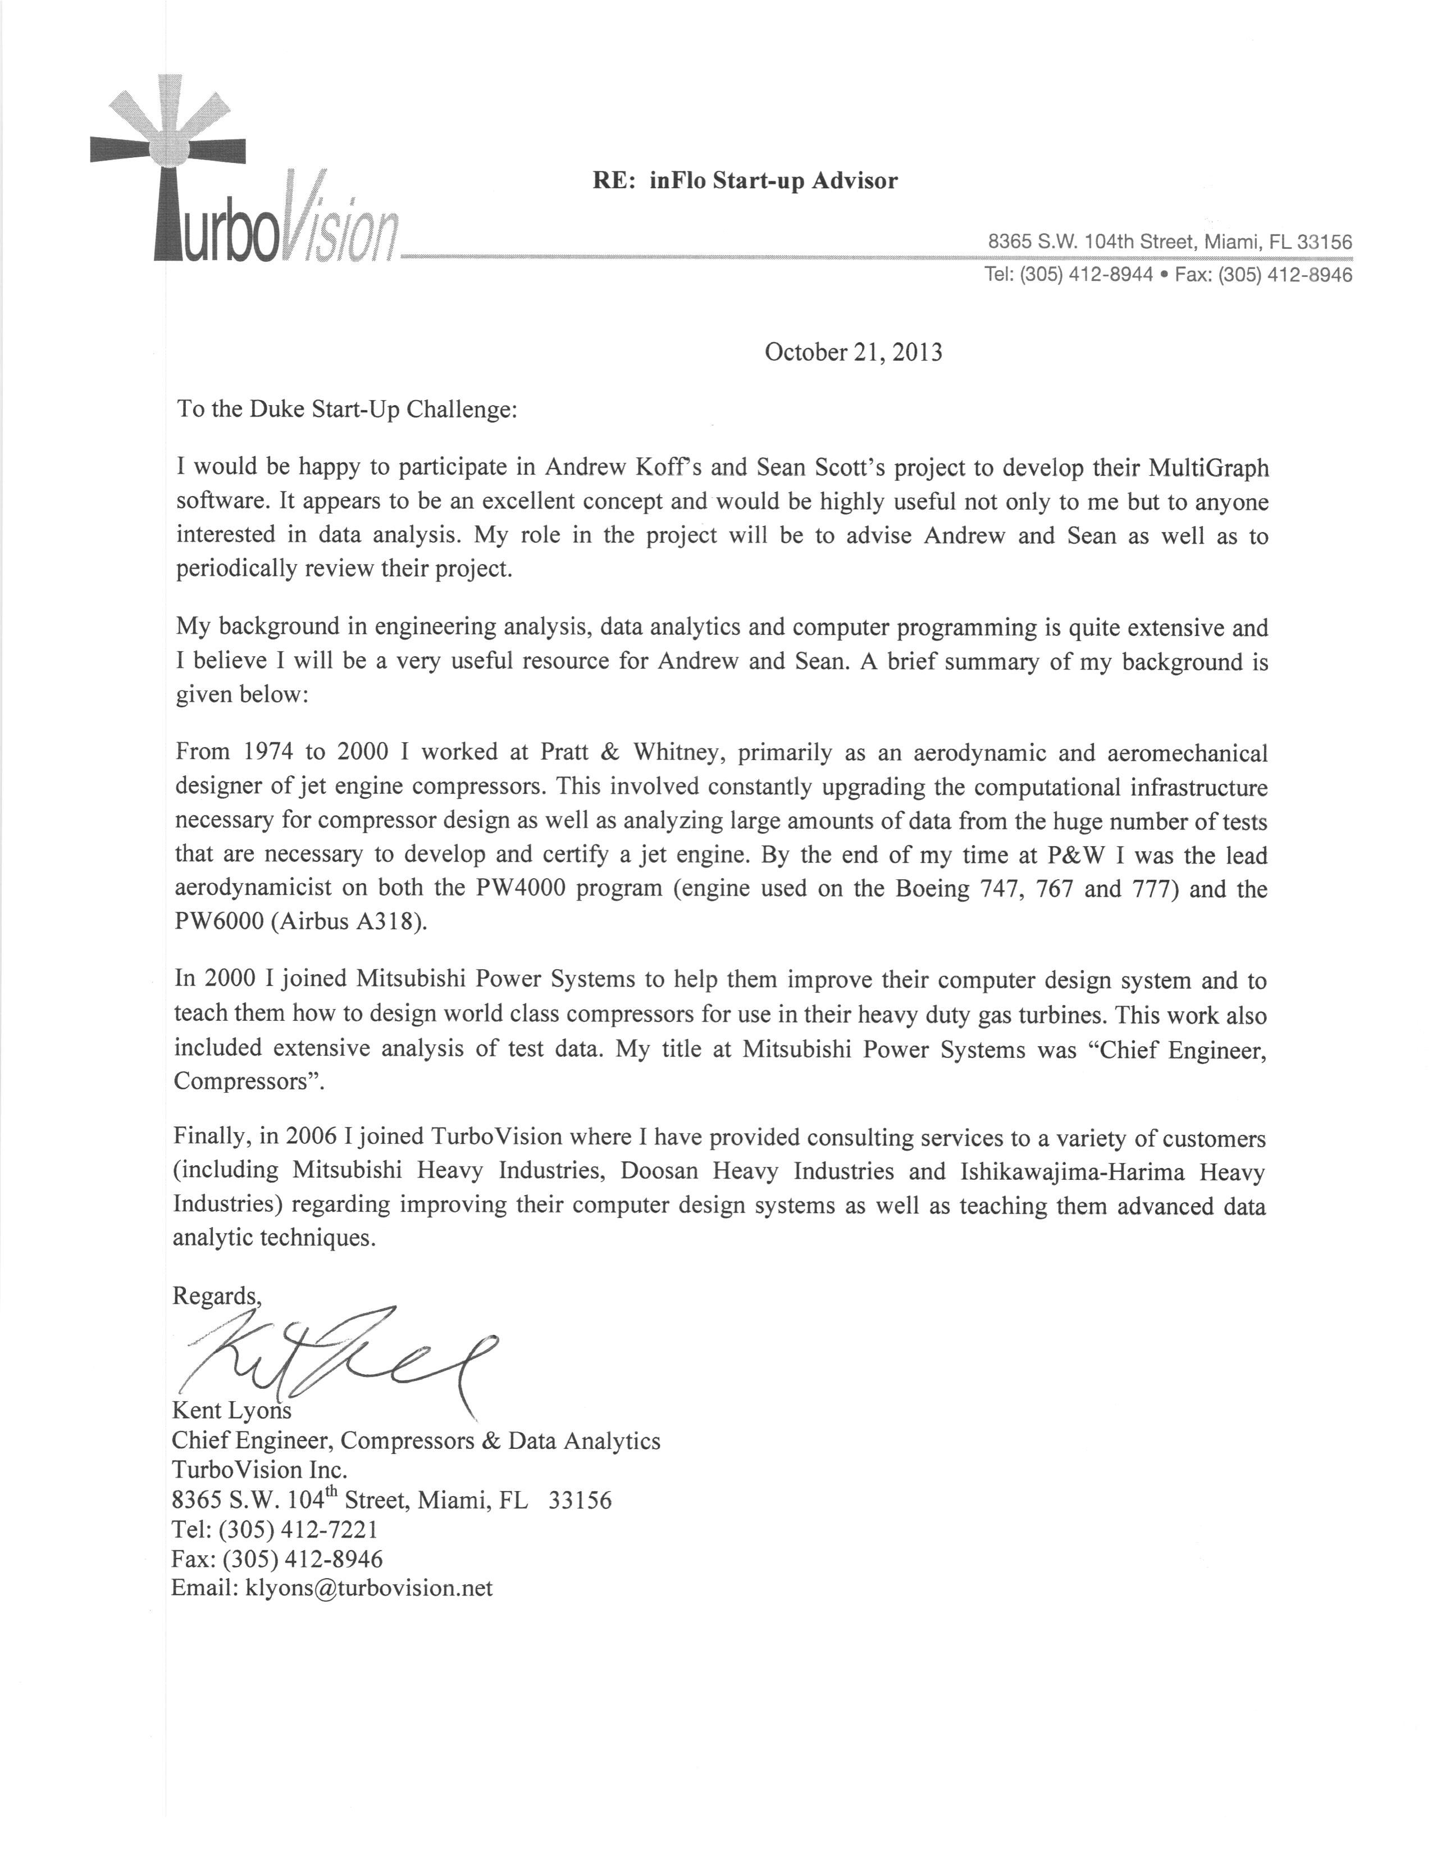

**Use of Funds - if you won $50,000 how would you use it?**

Winning the $50,000 grand prize would give us a major step forward in further developing Multigraph to its full capabilities, and marketing Multigraph to prospective customers and partners. First and foremost, purchasing software to enhance development capabilities would be essential not only for the growth of Multigraph as a product but also for the development of a pipeline for our company, inFlo. Our most urgent need in software tools deals with strengthening inFlo’s development of functionality in Multigraph; therefore, upgrading our Visual Studio software and purchasing MySQL for database development would be invaluable. Also, we would like to upgrade our software tools for interface development in order to improve the user experience of our product. Along with upgrading software, we are currently beginning to conduct testing for our initial product with our partner, TurboVision, which is an engineering design and consulting company. Thus capital would help make these efforts stronger and more productive. Our future plans include developing a web application for our product so that Multigraph can be reached through an Internet browser with data storage options for clients. This would further enhance our product in order to make it more useful for companies, and improve our marketing campaign.

Below is a more detailed view into how we would spend the $50,000 if we won the competition.

**Anything else you would like to share with us?**

**Although further development of inFlo’s software is currently in progress to make the software market ready, at the present time, our prototype code for Multigraph is being used in a business setting to achieve results that add value to our customers. The following are examples of current real life uses of inFlo’s software tool, Multigraph.**

**TurboVision Consulting Group Inc. uses initial version of Multigraph in its design of components for its power generation clients including Mitsubishi Heavy Industries, Ltd., and Doosan Heavy Industries& Construction Co., Ltd. For example….ADD LYONS STATEMENT OF USE**

1. Press, Gil. "Top Ten Big Data Pure-Plays. " Forbes.com. February 22, 2013. Retrieved September 5,2013.